# UW Data Science 350 – Winter 2017 Dave Wine 8430191

Problem

Simulate the Monty Hall problem to prove that winning a car is more likely (pCar = 0.666) if you switch your door than stay with your initial choice (pCar = 0.333).

Simulation Results

The idea is to show that as n gets large, the mean converges on the theoretical value. To do this, the game.instance function is run 3 times – for 10 games, 100 games, and 1000 game sets. This constitutes one set of results. Then (using the variable ‘m’ counter), 100 sets of such results are obtained. As can be seen by the graphs below, the most likely outcomes are centered on 1/3 of the total number of experiments (3, 33, 333) for ‘stay’ and likewise 2/3 (6, 66, 666) for ‘switch’:

Stay:

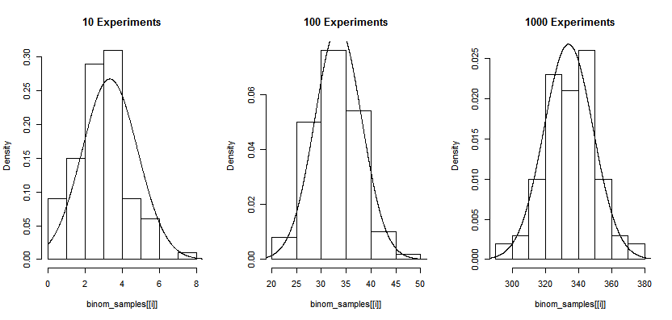

Switch:

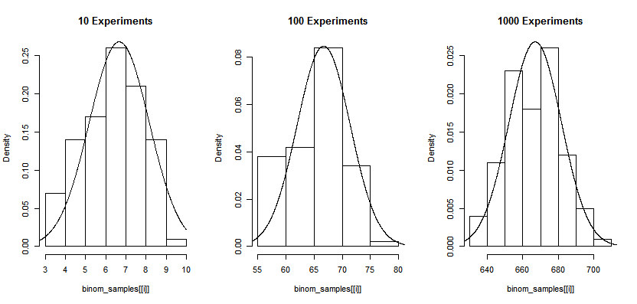

Now, the two sets of results can be combined on one graph:

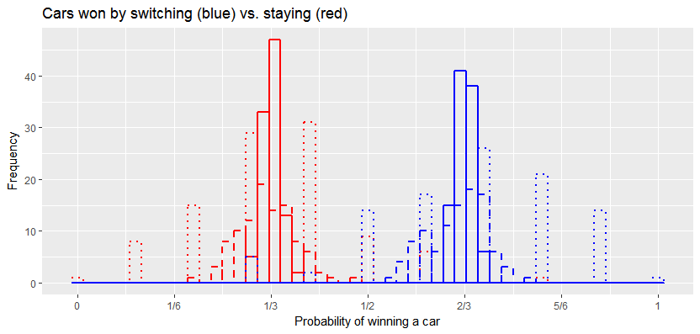

As can be seen, as the number of games played in a set increases from 10 (dotted lines) to 100 (dashed lines) to 1000 (solid lines), the most likely outcomes converge to 1/3 for staying (red) and 2/3 for switching (blue).